# Intellikeys USB Windows 10

February 12, 2019

Version 3.5 of the Intellikeys USB firmware loading driver supports both 32-bit and 64-bit Windows 10 up through version 1809.

Currently, installing the driver must be done manually.

To install the software on Windows 10:

1. Run “Setup.exe” from the Intellikeys CD. This will set up everything but the driver.
2. Connect the Intellikeys USB device to the computer. Windows should display two messages – first, that Windows is setting up an unknown device, followed by a message stating that the unknown device is ready to go.
3. Unzip the driver files. For 32-bit Windows, use IntellikeysUSB_Windows10_32bit_3.5_Feb_11_2019. For 64-bit Windows, use IntellikeysUSB_Windows10_64bit_3.5_Feb_11_2019.zip. If you’re not sure if you have 32-bit or 64-bit Windows, you can check the System control panel (right-click on the Windows Start menu (or press Windows + X on the keyboard), then select System. Look for the “System Type” – it should read “32-bit operating system” or “64-bit operating system.”  
   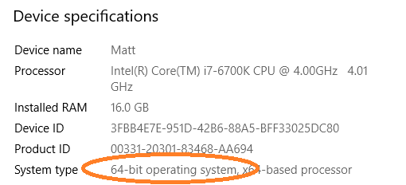
4. Open Windows Device Manager – right-click on the Windows Start menu (or press Windows + X on the keyboard), then select Device Manager from the pop-up menu. The Intellikeys keyboard should appear under “Other devices” as an “Unknown device”.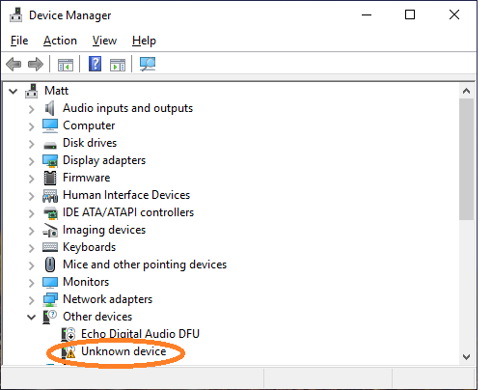
5. Right-click on the “Unknown device” in Device Manager and select “Update driver”. Then, select “Browse my computer for driver software.” Under “Search for drivers in this location”, choose the folder where you unzipped the driver files.

If successful, you’ll see a message saying “Intellikeys USB is ready to go”. The “Unknown device” should be gone from Device Manager, replaced by a “HID Keyboard Device” under Keyboards and “HID-compliant mouse” under “Mice and other pointing devices”.

Once the driver is installed, you will need to install the service and other support software.